**SUNBEAM CHRISTIAN SCHOOL OF PANABO**

QA Testing

➢ **Registrar:** Dashboard

➢ Put a More info that link to each page.

➢ Put the latest Announcement on the dashboard above the icons.

➢ Make the loader (place wait…) a little bit smaller cause it so distracting while loading and place it at the center.

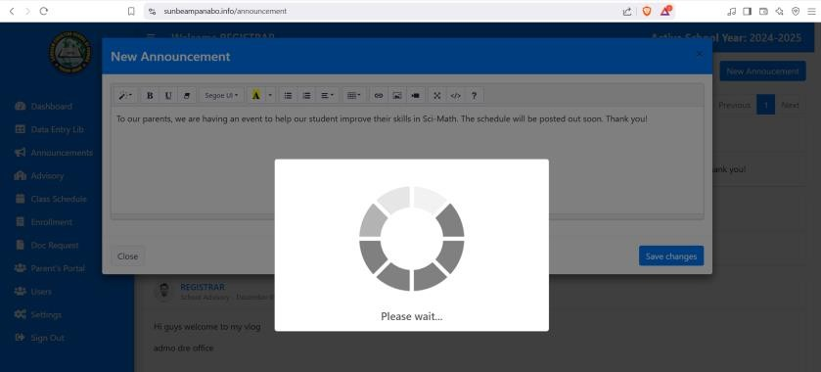

➢ Allow the registrar to edit his/her post. There is no Edit functionality. Use an Edit (pencil) icon button (use color blue) and put it at the right corner of each announcement. The Edit icon will show only within 24hrs after posted.

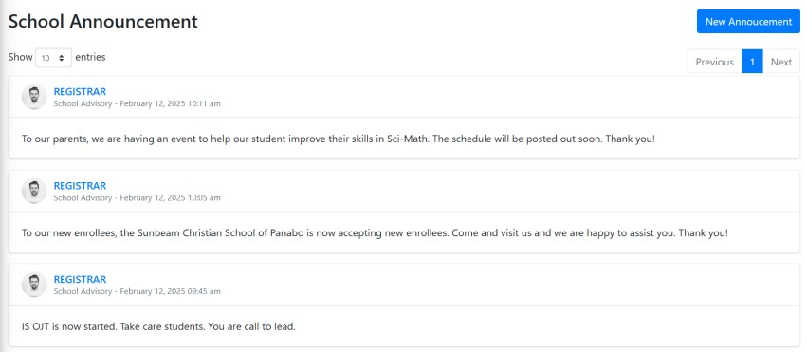

➢ Put the total number of announcements that has been posted. Place it below the heading. The total number of announcements should be the same on the Dashboard.

➢ **Registrar:** Teacher

➢ Make the loader (place wait…) a little bit smaller cause it so distracting while loading and place it at the center.

|  |  |  |
| --- | --- | --- |
| ➢ | **Regist** | **rar:** Student |

➢ **Profile Info (Update):** Click on View button

➢ Make the loader (place wait…) a little bit smaller cause it so distracting while loading and place it at the center.

➢ Make the loader (place wait…) a little bit smaller cause it so distracting while loading and place it at the center.

➢ Make the loader (place wait…) a little bit smaller cause it so distracting while loading and place it at the center.

➢ **Student Info (Grades):** Click on Click on Print Grade Card

➢ Make the loader (place wait…) a little bit smaller cause it so distracting while loading and place it at the center.

➢ Make the loader (place wait…) a little bit smaller cause it so distracting while loading and place it at the center.

➢

➢ Make the loader (place wait…) a little bit smaller cause it so distracting while loading and place it at the center.

➢

➢ **Teacher:** Dashboard

➢ Show the total amount of data on the dashboard. Make it dynamic. Follow the naming below:

➢ Change My Students Count to “Total Student”

➢ Change My Subjects to “Total Subject”

➢ Change Grade Sections to “Total Grade Section”

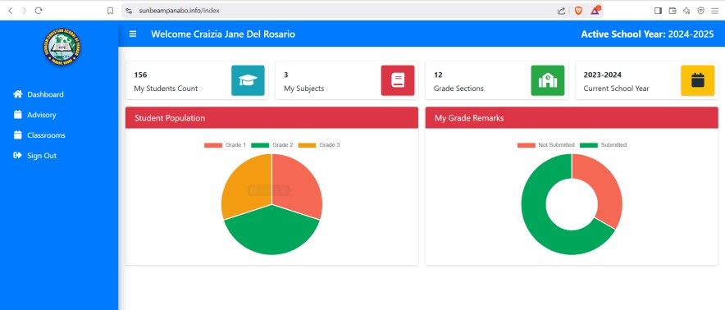

➢ Show the actual amount of data in the Student Population chart. Make it dynamic.

➢ Show the actual amount of data in the My Grade Remarks chart. Make it dynamic.

➢ The chart should coincide to the total number of students in the Total Student.

➢ Remove the Current School Year.

➢ To display the teacher dashboard, follow the sample from Registrar dashboard below:

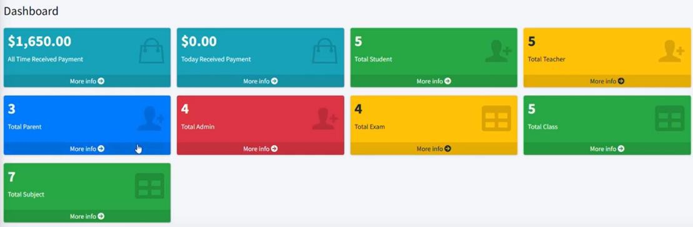

➢ Put the latest Announcement from the registrar and place it above the icons.

➢ **Teacher:** Advisory

➢ **Action button (view advisory and announcement):** change the button padding to “padding:

5px” and line-height to “line-height: 2.5”

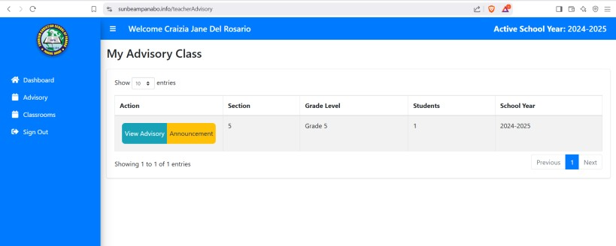

➢ Make the loader (place wait…) a little bit smaller cause it so distracting while loading and place it at the center.

➢ **Teacher:** Classroom

➢ Make the loader (place wait…) a little bit smaller cause it so distracting while loading and place it at the center.

➢ **Parent:** Dashboard

➢ **Parent:** My Student

➢ Make the loader (place wait…) a little bit smaller cause it so distracting while loading and place it at the center.

➢ **Parent:** Online Payment

➢ Details button has no function yet to view the detail of the online payment. Change the button name to “View Detail”.

➢ **Pay Online button:** Put the modal pop up at the center of the page. Give instructions on how to pay online inside. Change the title heading to: “Pay Online”

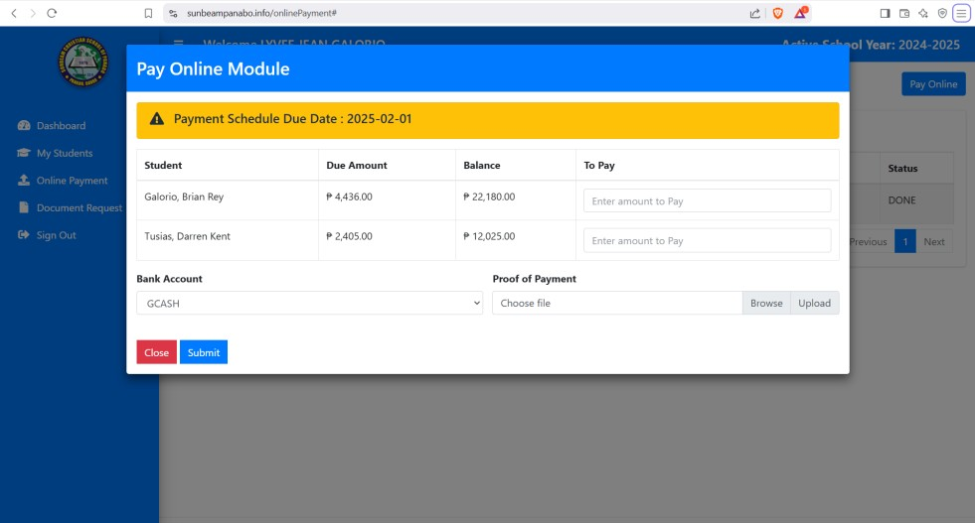

➢ If Gcash is the mode of payment, automate the payment by using the QR Code.

➢ **Parent:** Document Request

➢ Instead of “Document Request Module”, change the title heading to “Document Request”. The

Delete button is not functional. Allow the parent to delete the files form the list.



